**Department of Electrical Engineering and   
Computer Science**

**Faculty Member:** Dr. Arbab Latif  **Dated:** 31/01/2022

**Semester:** 4th **Section:** BEE 12C

**EE-222: Microprocessor Systems**

Lab 1: Simulation and Hardware Implementation

Group Members

|  |  |  |  |  |
| --- | --- | --- | --- | --- |
| **Name** | **Reg. No** | **Report**  **Marks / 10** | **Viva**  **Marks / 5** | **Total**  **Marks / 15** |
| Danial Ahmad | 331388 |  |  |  |
| Muhammad Umer | 345834 |  |  |  |
|  |  |  |  |  |
|  |  |  |  |  |

# Experiment

# Simulation and Hardware Implementation

## Objectives

1. Familiarization with Universal
2. Understanding assembly code implementation
3. Burning HEX files into ATmega16A using SUPERPRO
4. Implement a basic circuit involving ATmega16A on breadboard

## Equipment

Software

* *Atmel Studio*
* *Universal Programmer (SUPERPRO)*

Hardware

* *LEDs*
* *Digital Trainer Kit*
* *ATmega16A Microcontroller Unit*

## Introduction

Programming methods all follow one basic procedure: the device to be programmed is connected to the programmer, either by plugging it into a socket on the programmer or connecting the programmer via an adapter to the board that contains the device. Once that occurs, data is then transferred to the device by applying signals to the connecting pins using pin-driver circuits. Xetel SUPERPRO Universal Programmer was utilized to accomplish that in this particular lab.



In this half of the lab, we burn the .HEX file produced through building and compiling the assembly code in Atmel Studio onto the actual Microprocessor, ATmega16A, through and with the help of Universal Programmer. For the present case, we used Xeltek SUPERPRO to fulfill our needs. This was immediately followed by hardware implementation of the ATmega16A on a breadboard. Using the 8 LEDs of the trainer kit, we verified the functionality of our code after making appropriate connections.

A small change was made in the inner loop (idle loop), **ldi R20, 0x0F** to **ldi R20, 0xFF**, which effectively increases the time it takes to execute each cycle.

## Assembly Code

**; Latter Half**

**; Lab1.asm**

**;**

**; Created: 07/02/2022 6:51:55 pm**

**; Author : Muhammad Umer and Danial Ahmad**

**;**

**; initial constants**

**ldi R16, 0xFF**

**ldi R17, 0xFF**

**; set DDRB as output**

**out DDRA, R17**

**; code to toggle LEDs**

**toggler:**

**subi R16, 0xFF**

**out PORTA, R16**

**rjmp idle_loop**

**; delay loop**

**idle_loop :**

**ldi R19, 0xFF**

**ldi R20, 0xFF**

**ldi R21, 0x01**

**idle_loop_0 :**

**idle_loop_1 :**

**idle_loop_2 :**

**dec R19**

**brne idle_loop_2**

**dec R20**

**brne idle_loop_1**

**dec R21**

**brne idle_loop_0**

**rjmp toggler**

## Debug Screenshots

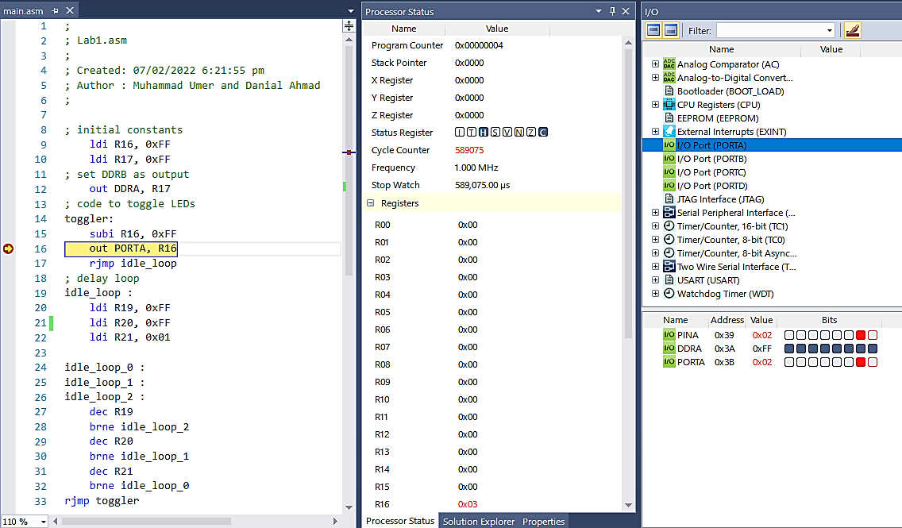

***Iteration 3***

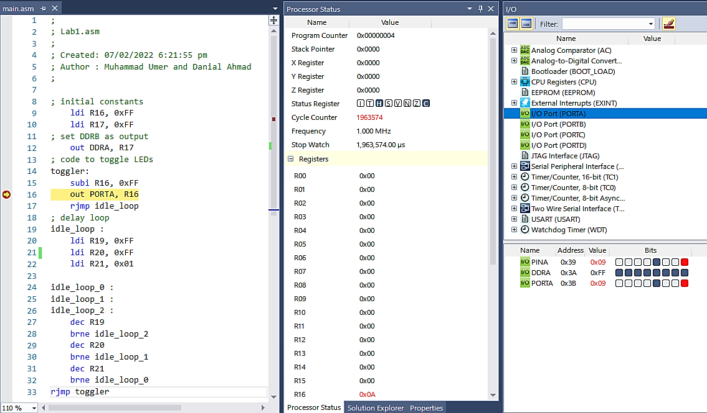

***Iteration 11***

## Simulation Derivations – Tabular Data

## Iteration 1

|  |  |  |  |  |  |  |  |  |
| --- | --- | --- | --- | --- | --- | --- | --- | --- |
| **Cycle Counter** | I | T | H | S | V | N | Z | C |
| 0 | 0 | 0 | 0 | 0 | 0 | 1 | 0 |
| **Cycles** | 4 | | | | | | | |
| **Time** | 4 µs | | | | | | | |
| **R16** | 0x00 | | | | | | | |
| **PORTA** | 0 | 0 | 0 | 0 | 0 | 0 | 0 | 0 |

## Iteration 2

|  |  |  |  |  |  |  |  |  |
| --- | --- | --- | --- | --- | --- | --- | --- | --- |
| **Cycle Counter** | I | T | H | S | V | N | Z | C |
| 0 | 0 | 1 | 0 | 0 | 0 | 0 | 1 |
| **Cycles** | 196361 – 4 = 196357 | | | | | | | |
| **Time** | 196357 µs | | | | | | | |
| **R16** | 0x01 | | | | | | | |
| **PORTA** | 0 | 0 | 0 | 0 | 0 | 0 | 0 | 0 |

## Iteration 3

|  |  |  |  |  |  |  |  |  |
| --- | --- | --- | --- | --- | --- | --- | --- | --- |
| **Cycle Counter** | I | T | H | S | V | N | Z | C |
| 0 | 0 | 1 | 0 | 0 | 0 | 0 | 1 |
| **Cycles** | 392718 – 196361 = 196357 | | | | | | | |
| **Time** | 196357 µs | | | | | | | |
| **R16** | 0x02 | | | | | | | |
| **PORTA** | 0 | 0 | 0 | 0 | 0 | 0 | 0 | 1 |

## Iteration 4

|  |  |  |  |  |  |  |  |  |
| --- | --- | --- | --- | --- | --- | --- | --- | --- |
| **Cycle Counter** | I | T | H | S | V | N | Z | C |
| 0 | 0 | 1 | 0 | 0 | 0 | 0 | 1 |
| **Cycles** | 589075 – 392718 = 196357 | | | | | | | |
| **Time** | 196357µs | | | | | | | |
| **R16** | 0x03 | | | | | | | |
| **PORTA** | 0 | 0 | 0 | 0 | 0 | 0 | 1 | 0 |

## Iteration 5

|  |  |  |  |  |  |  |  |  |
| --- | --- | --- | --- | --- | --- | --- | --- | --- |
| **Cycle Counter** | I | T | H | S | V | N | Z | C |
| 0 | 0 | 1 | 0 | 0 | 0 | 0 | 1 |
| **Cycles** | 785432 – 589075 = 196357 | | | | | | | |
| **Time** | 196357 µs | | | | | | | |
| **R16** | 0x04 | | | | | | | |
| **PORTA** | 0 | 0 | 0 | 0 | 0 | 0 | 1 | 1 |

## Iteration 6

|  |  |  |  |  |  |  |  |  |
| --- | --- | --- | --- | --- | --- | --- | --- | --- |
| **Cycle Counter** | I | T | H | S | V | N | Z | C |
| 0 | 0 | 1 | 0 | 0 | 0 | 0 | 1 |
| **Cycles** | 981789 – 785432 = 196357 | | | | | | | |
| **Time** | 196357 µs | | | | | | | |
| **R16** | 0x05 | | | | | | | |
| **PORTA** | 0 | 0 | 0 | 0 | 0 | 1 | 0 | 0 |

## Iteration 7

|  |  |  |  |  |  |  |  |  |
| --- | --- | --- | --- | --- | --- | --- | --- | --- |
| **Cycle Counter** | I | T | H | S | V | N | Z | C |
| 0 | 0 | 1 | 0 | 0 | 0 | 0 | 1 |
| **Cycles** | 1178146 – 981789 = 196357 | | | | | | | |
| **Time** | 196357 µs | | | | | | | |
| **R16** | 0x06 | | | | | | | |
| **PORTA** | 0 | 0 | 0 | 0 | 0 | 1 | 0 | 1 |

## Iteration 8

|  |  |  |  |  |  |  |  |  |
| --- | --- | --- | --- | --- | --- | --- | --- | --- |
| **Cycle Counter** | I | T | H | S | V | N | Z | C |
| 0 | 0 | 1 | 0 | 0 | 0 | 0 | 1 |
| **Cycles** | 1374503 – 1178146 = 196357 | | | | | | | |
| **Time** | 196357 µs | | | | | | | |
| **R16** | 0x07 | | | | | | | |
| **PORTA** | 0 | 0 | 0 | 0 | 0 | 1 | 1 | 0 |

## Iteration 8

|  |  |  |  |  |  |  |  |  |
| --- | --- | --- | --- | --- | --- | --- | --- | --- |
| **Cycle Counter** | I | T | H | S | V | N | Z | C |
| 0 | 0 | 1 | 0 | 0 | 0 | 0 | 1 |
| **Cycles** | 1570860 – 1374503 = 196357 | | | | | | | |
| **Time** | 196357 µs | | | | | | | |
| **R16** | 0x08 | | | | | | | |
| **PORTA** | 0 | 0 | 0 | 0 | 0 | 1 | 1 | 1 |

## Iteration 10

|  |  |  |  |  |  |  |  |  |
| --- | --- | --- | --- | --- | --- | --- | --- | --- |
| **Cycle Counter** | I | T | H | S | V | N | Z | C |
| 0 | 0 | 1 | 0 | 0 | 0 | 0 | 1 |
| **Cycles** | 1767217 – 1570860 =196357 | | | | | | | |
| **Time** | 196357 µs | | | | | | | |
| **R16** | 0x09 | | | | | | | |
| **PORTA** | 0 | 0 | 0 | 0 | 1 | 0 | 0 | 0 |

## Iteration 11

|  |  |  |  |  |  |  |  |  |
| --- | --- | --- | --- | --- | --- | --- | --- | --- |
| **Cycle Counter** | I | T | H | S | V | N | Z | C |
| 0 | 0 | 1 | 0 | 0 | 0 | 0 | 1 |
| **Cycles** | 1963574 – 1767217 = 196357 | | | | | | | |
| **Time** | 196357 µs | | | | | | | |
| **R16** | 0x0A | | | | | | | |
| **PORTA** | 0 | 0 | 0 | 0 | 1 | 0 | 0 | 1 |

## Iteration 12

|  |  |  |  |  |  |  |  |  |
| --- | --- | --- | --- | --- | --- | --- | --- | --- |
| **Cycle Counter** | I | T | H | S | V | N | Z | C |
| 0 | 0 | 1 | 0 | 0 | 0 | 0 | 1 |
| **Cycles** | 2159931 – 1963574 = 196357 | | | | | | | |
| **Time** | 196357 µs | | | | | | | |
| **R16** | 0x0B | | | | | | | |
| **PORTA** | 0 | 0 | 0 | 0 | 1 | 0 | 1 | 0 |

## Iteration 13

|  |  |  |  |  |  |  |  |  |
| --- | --- | --- | --- | --- | --- | --- | --- | --- |
| **Cycle Counter** | I | T | H | S | V | N | Z | C |
| 0 | 0 | 1 | 0 | 0 | 0 | 0 | 1 |
| **Cycles** | 2356288 – 2159931 = 196357 | | | | | | | |
| **Time** | 196357 µs | | | | | | | |
| **R16** | 0x0C | | | | | | | |
| **PORTA** | 0 | 0 | 0 | 0 | 1 | 0 | 1 | 1 |

## Iteration 14

|  |  |  |  |  |  |  |  |  |
| --- | --- | --- | --- | --- | --- | --- | --- | --- |
| **Cycle Counter** | I | T | H | S | V | N | Z | C |
| 0 | 0 | 1 | 0 | 0 | 0 | 0 | 1 |
| **Cycles** | 2552645 – 2356288 = 196357 | | | | | | | |
| **Time** | 196357 µs | | | | | | | |
| **R16** | 0x0D | | | | | | | |
| **PORTA** | 0 | 0 | 0 | 0 | 1 | 1 | 0 | 0 |

## Iteration 15

|  |  |  |  |  |  |  |  |  |
| --- | --- | --- | --- | --- | --- | --- | --- | --- |
| **Cycle Counter** | I | T | H | S | V | N | Z | C |
| 0 | 0 | 1 | 0 | 0 | 0 | 0 | 1 |
| **Cycles** | 2749002 – 2552645 = 196357 | | | | | | | |
| **Time** | 196357 µs | | | | | | | |
| **R16** | 0x0E | | | | | | | |
| **PORTA** | 0 | 0 | 0 | 0 | 1 | 1 | 0 | 1 |

## Iteration 16

|  |  |  |  |  |  |  |  |  |
| --- | --- | --- | --- | --- | --- | --- | --- | --- |
| **Cycle Counter** | I | T | H | S | V | N | Z | C |
| 0 | 0 | 1 | 0 | 0 | 0 | 0 | 1 |
| **Cycles** | 2945359 – 2749002 = 196357 | | | | | | | |
| **Time** | 196357 µs | | | | | | | |
| **R16** | 0x0F | | | | | | | |
| **PORTA** | 0 | 0 | 0 | 0 | 1 | 1 | 1 | 0 |

## Iteration 17

|  |  |  |  |  |  |  |  |  |
| --- | --- | --- | --- | --- | --- | --- | --- | --- |
| **Cycle Counter** | I | T | H | S | V | N | Z | C |
| 0 | 0 | 0 | 0 | 0 | 0 | 0 | 1 |
| **Cycles** | 3141716 – 2945359 = 196357 | | | | | | | |
| **Time** | 196357 µs | | | | | | | |
| **R16** | 0x10 | | | | | | | |
| **PORTA** | 0 | 0 | 0 | 0 | 1 | 1 | 1 | 1 |

## Iteration 18

|  |  |  |  |  |  |  |  |  |
| --- | --- | --- | --- | --- | --- | --- | --- | --- |
| **Cycle Counter** | I | T | H | S | V | N | Z | C |
| 0 | 0 | 1 | 0 | 0 | 0 | 0 | 1 |
| **Cycles** | 3338073 – 3141716 = 196357 | | | | | | | |
| **Time** | 196357 µs | | | | | | | |
| **R16** | 0x11 | | | | | | | |
| **PORTA** | 0 | 0 | 0 | 1 | 0 | 0 | 0 | 0 |

## Iteration 19

|  |  |  |  |  |  |  |  |  |
| --- | --- | --- | --- | --- | --- | --- | --- | --- |
| **Cycle Counter** | I | T | H | S | V | N | Z | C |
| 0 | 0 | 1 | 0 | 0 | 0 | 0 | 1 |
| **Cycles** | 3534430 – 3338073 = 196357 | | | | | | | |
| **Time** | 196357 µs | | | | | | | |
| **R16** | 0x12 | | | | | | | |
| **PORTA** | 0 | 0 | 0 | 1 | 0 | 0 | 0 | 1 |

## Iteration 20

|  |  |  |  |  |  |  |  |  |
| --- | --- | --- | --- | --- | --- | --- | --- | --- |
| **Cycle Counter** | I | T | H | S | V | N | Z | C |
| 0 | 0 | 1 | 0 | 0 | 0 | 0 | 1 |
| **Cycles** | 3730787 – 3534430 = 196357 | | | | | | | |
| **Time** | 196357 µs | | | | | | | |
| **R16** | 0x13 | | | | | | | |
| **PORTA** | 0 | 0 | 0 | 1 | 0 | 0 | 1 | 0 |

## Simulation Derivations – Observations

* From this tabular data, and by looking at the results of the first 20 iterations, we can conclusively say that our assembly code essentially acts as a binary up counter, as the value of R16 increments by 1 after each iteration.
* PORTA provides 8 – bit positions for the binary representation of the counter.
* The change of **0x0F to 0xFF** in the idle loop of our code increased the time delay in the execution of each cycle. This is particularly helpful in order to observe and verify our hardware implementation

## Hardware Implementation

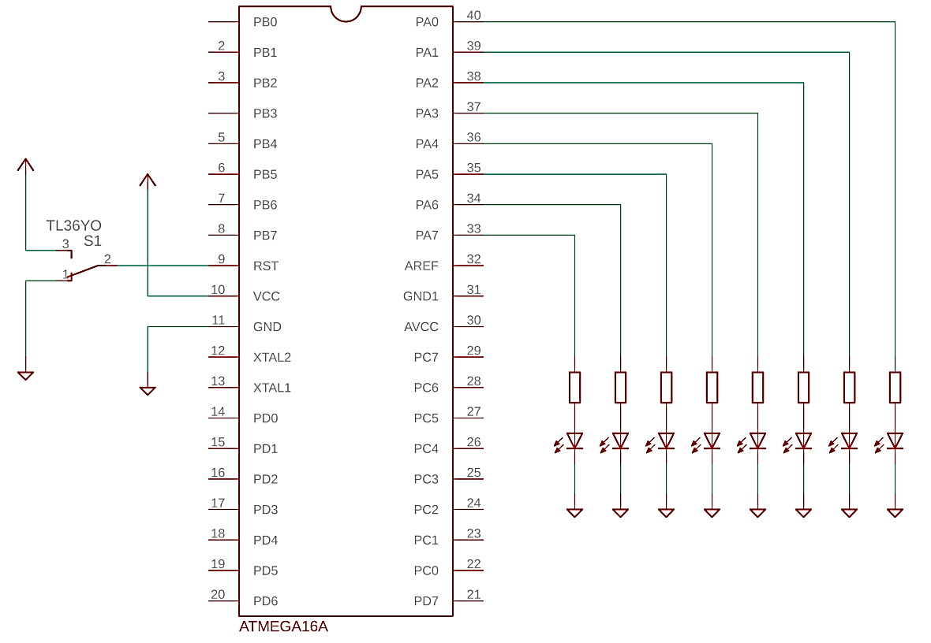

***Schematic***



***Demonstration***

## Conclusion

After the conduction of this lab, we have learnt how to use a Universal Programmer Toolkit, taking into account both its hardware and software aspects. We burnt the .HEX file, produced by the compilation of assembly code by Atmel Studio, onto ATmega16A using SUPERPRO’s software port. We also verified the output of the now-ready MCU by patching up a simple circuit on the breadboard, in accordance with the lab manual, and verified the lighting patterns of the LEDs on the trainer kit.

*An animation of the lab demonstration has been attached above (refer to Hardware Implementation section).*